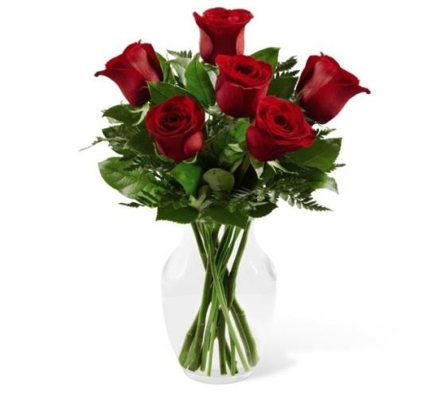

**A-208 Romance USD 60**

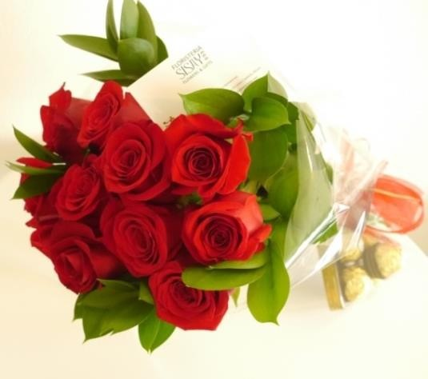

Fresh Flower Arrangements Delivered to you!

A-211 Roses Bouquet (12)

with chocolates

USD 90

A-205 Thinking of you 90 USD 790

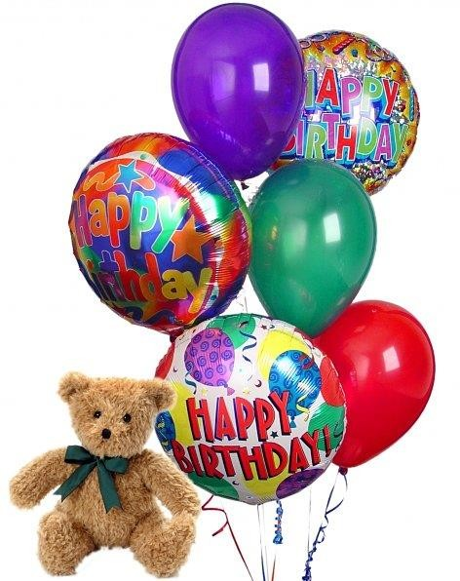

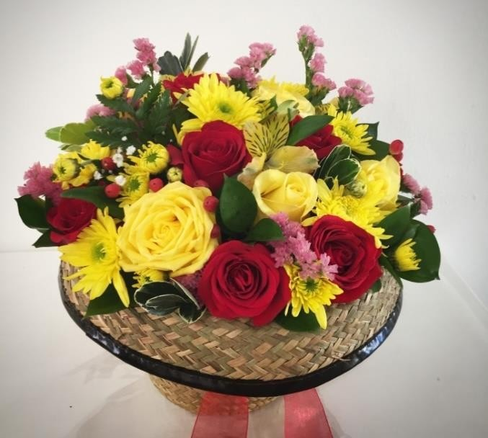

**A-209 Sunny Day USD 95**

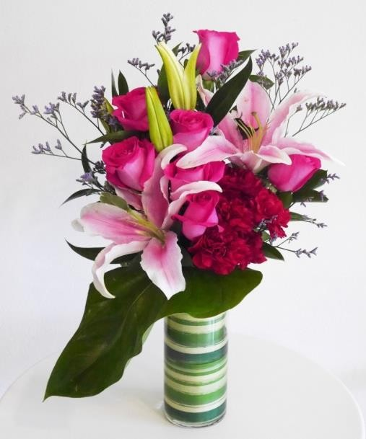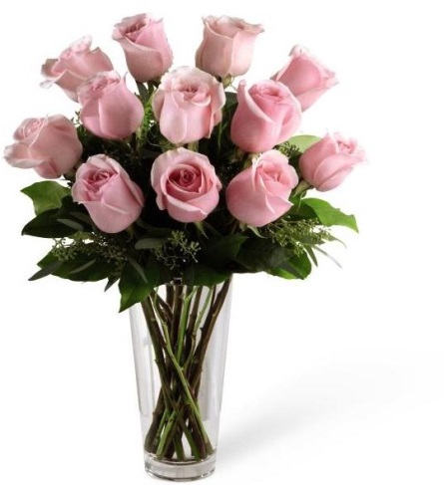

**A-207 Love in Pink 100 USD**

9218 Bouquet Balloons (6)

with Teddy bear USD 90



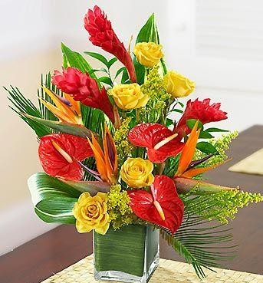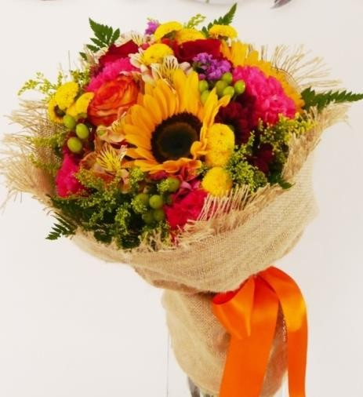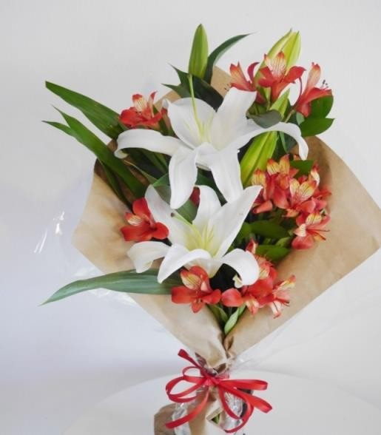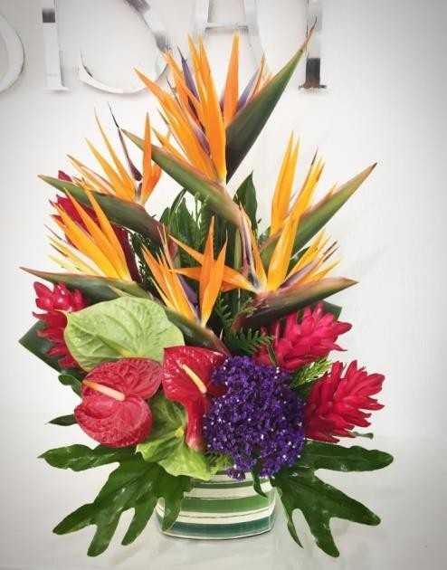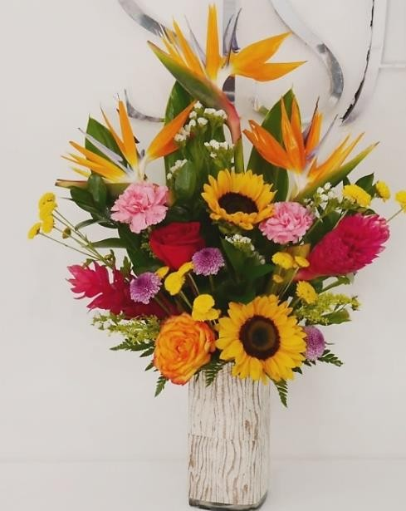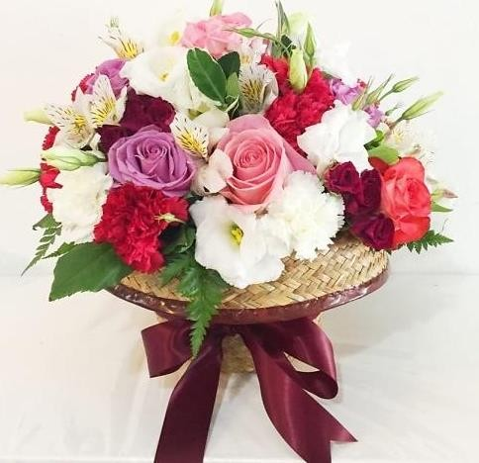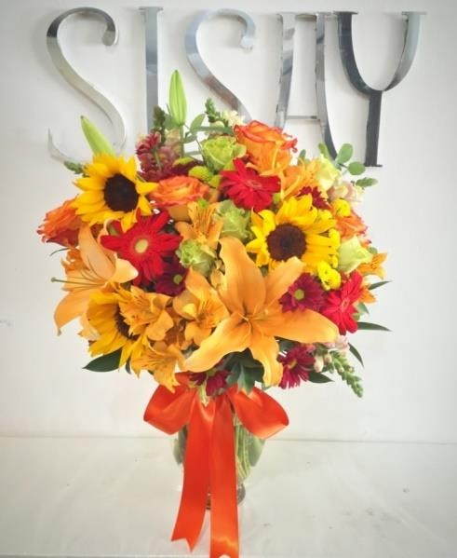

A-203 Caribbean Sun

A-217 My Sweet heart

USD

90

USD

95

A-80 Tropical Surprise USD 90

A-212 Sweet Lilies USD 55

A-134 Tropical Heart USD 80

A-214 Caribbean Adventure USD 105

A-216 Wild Passion USD 90

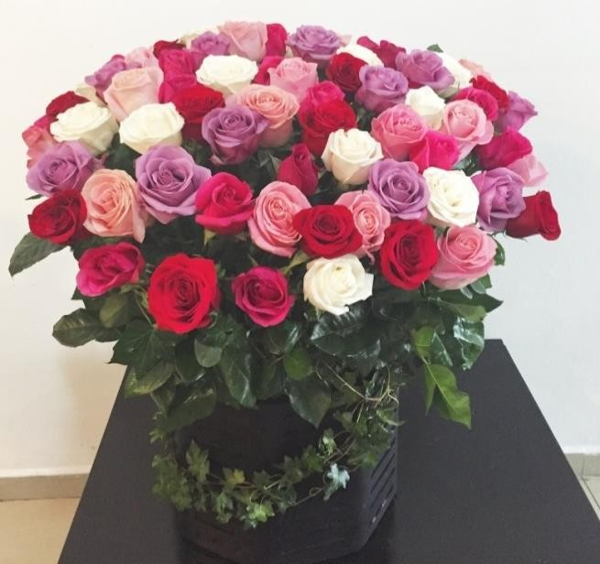

A-213 Roses arrangement (55) USD 210

USD14 USD14 USD16 USD12 USD20

Metallic Balloons 18” from Helium Balloons 18” from Box of chocolates from Petals Bag

Teddy Bear from

**Delivery USD 10**

**Make It Extra Special / Choose**

**Some Extras**